**Index**

|  |  |
| --- | --- |
| **S.NO** | **CONTENTS** |
| 1 | Course Details |
| 2 | Syllabus |
| 3 | Course Outcomes(CO), CO-PO and PSO Mapping |
| 4 | University Calendar |
| 5 | Mid-1 Question Paper |
| 6 | CAA1 Question paper |
| 7 | Remedial class time table |
| 8 | Mid-2 Question Paper |
| 9 | CAA2 Question Paper |
| 10 | Course mid marks |
| 11 | Course Question Bank |
| 12 | Course previous Question Papers |
| 13 | Student Feedback analysis and Action taken |
| 14 | University Exam Question Paper & Result Analysis |
| 15 | Course Outcome Attainment (COA) |
| 16 | Reports on COA |
| 17 | Google class room link Course Material |
| 18 | Pedagogy report |

### SRINIVASA RAMANUJAN INSTITUTE OF TECHNOLOGY



(Affiliated to JNTUA & Approved by AICTE and Accredited by NAAC with A Grade,Accredited by NBA(ECE,EEE,CSE))

Rotarypuram Village, B K Samudram Mandal, Ananthapuramu - 515701.

Department of Computer Science and Engineering

|  |  |  |  |  |  |  |
| --- | --- | --- | --- | --- | --- | --- |
| **Course Title:** | **Computer Networks** | | | | **Course Code:** | **R204GA05502** |
| **Class & Sem:** | **III B. Tech I Sem** | | | | **Regulations:** | **SRIT-R20** |
| **Course Structure:** | **Theory** | **Tutorial** | **Lab** | **Credits** | **Core/Elective:** | **Core** |
| **3** | **0** | **0** | **3** |
| **Instructor 1:** | **C.Lakshminatha Reddy** | | | **Instructor 2:** |  | **AY: 2021-22** |

1. **Prerequisites:** Networks, Data Communications, network security mechanisms.
2. **Course Description:** This course deals with the concepts of computer network introduction, OSI layers, physical layer, Data link layer, communication layer, Network layer, Application layer, Network security & Cryptography.

###### Detailed Syllabus:

**UNIT – I: (16 Periods)**

**Introduction:** Uses of Computer Networks, Network Hardware, Network Software, Reference Models.

**Physical Layer:** Theoretical basis for Data Communications, Transmission media, Circuit Switching and Packet Switching.

###### UNIT – II: (12 Periods)

**Data Link Layer:** Design issues, Error Detection and Correction Layer, Elementary Data Link Protocols, Sliding Window Protocols, Example Data Link Protocols.

**Medium Access Control Layer:** Channel Allocation Problem, Multiple Access Protocols, Ethernet, Wireless LAN.

###### UNIT – III: (11 Periods)

**Network Layer:** Design issues, Routing Algorithms, Congestion Control Algorithms, Quality of Service, Internetworking, and Network Layer in the internet.

**Transport Layer:** Transport Services, Elements of Transport Protocols, Congestion Control, UDP, TCP, Performance issues, Delay-Tolerant Networking.

###### UNIT – IV: (10 Periods)

**Application Layer:** DNS, Remote Logging, File Transfer, Electronic-Mail, WWW, HTTP, Network Management Systems, SNMP, Streaming Audio and Video, Content Delivery.

###### UNIT – V: (11 Periods)

**Network Security:** Cryptography, Symmetric-key Algorithms, Public-Key Algorithms, Digital Signatures, Management of Public keys, Communication Security, Authentication Protocols, Email Security, Web Security and Social issues.

###### Total Periods: 60

1. **Text Books:**
   1. “Computer Networks”, Andrew S. Tanenbaum and David J. Wetharall, Prentice Hall, fifth Edition, 2011.
   2. “Data Communications and Networking”, Behrouz A. Forouzon, Sophia Chung Fegan, McGraw Hill Higher Education fifth Edition, 2012.

###### Reference Books:

* 1. “Computer Networks: A Systems Approach”, Larry Peterson and Bruce Davie, 5th Ed, The Morgan Kaufmann Series, Elsevier, 2011.
  2. “Computer Networking: A Top-Down Approach Featuring the Internet”, J.F. Kurose and K.W.Ross, 6th Ed., Pearson Education, 2012.“Data and Computer Communications”, William Stallings, Pearson Education, 10th Ed, 2013

###### Course Outcomes:

On successful completion of this course the students will be able to

|  |  |  |
| --- | --- | --- |
| **S.No** | **Course Outcomes** | **Cognitive Level** |
| 1 | Examine the different building blocks of Communication network and its architecture. | Understand |
| 2 | Contrast different types of networks and analyze the performance of network. | Understand |
| 3 | Identify and examine the various solutions in design issues of Data Link Layer. | Apply |
| 4 | Compare and Contrast various types of Routing Algorithms and Congestion Control Algorithms. | Apply |
| 5 | Illustrate fundamentals of transport services, protocols, congestion control implantation and its performance. | Understand |
| 6 | Illustrate Fundamental applications of Application Layer and its Security mechanisms. | Understand |

1. **Additional Topics:**

|  |  |  |
| --- | --- | --- |
| **Sr. No.** | **Topic** | **Course Outcome** |
| **1** | Demonstrating how working packet tracer tool. |  |
| **2** | Demonstrating session layer ,presentation layer. |  |

1. **Course Assessment & Evaluation:**

|  |  |  |
| --- | --- | --- |
| **Mode of assessment** | **Frequency** | **Marks** |
| Mid-Term Examinations (Internal) | Twice  (80% weightage to the better mid exam and 20% to the  other) | 40 |
| University Examinations (External) | Once | 60 |
| **Total** | | **100** |

1. **Mapping(X) of Course Outcomes with Program Outcomes & Program Specific Outcomes:**

|  |  |  |  |  |  |  |  |  |  |  |  |  |  |  |  |
| --- | --- | --- | --- | --- | --- | --- | --- | --- | --- | --- | --- | --- | --- | --- | --- |
| **CO/PO** | **PO1** | **PO2** | **PO3** | **PO4** | **PO5** | **PO6** | **PO7** | **PO8** | **PO9** | **PO10** | **PO11** | **PO12** | **PSO1** | **PSO2** | **PSO3** |
| **CO1** | X |  |  |  |  |  |  |  |  |  |  |  | X |  |  |
| **CO2** | X | X |  |  |  |  |  |  |  |  |  |  | X |  |  |
| **CO3** | X | X |  |  |  |  |  |  |  |  |  |  | X |  |  |
| **CO4** | X | X |  |  |  |  |  |  |  |  |  |  | X |  |  |
| **CO5** | X | X |  |  |  |  |  |  |  |  |  |  | X |  |  |
| **CO6** | X |  |  |  | X |  |  |  |  |  |  |  | X |  |  |

**Course Instructor HOD**

**University Calendar**

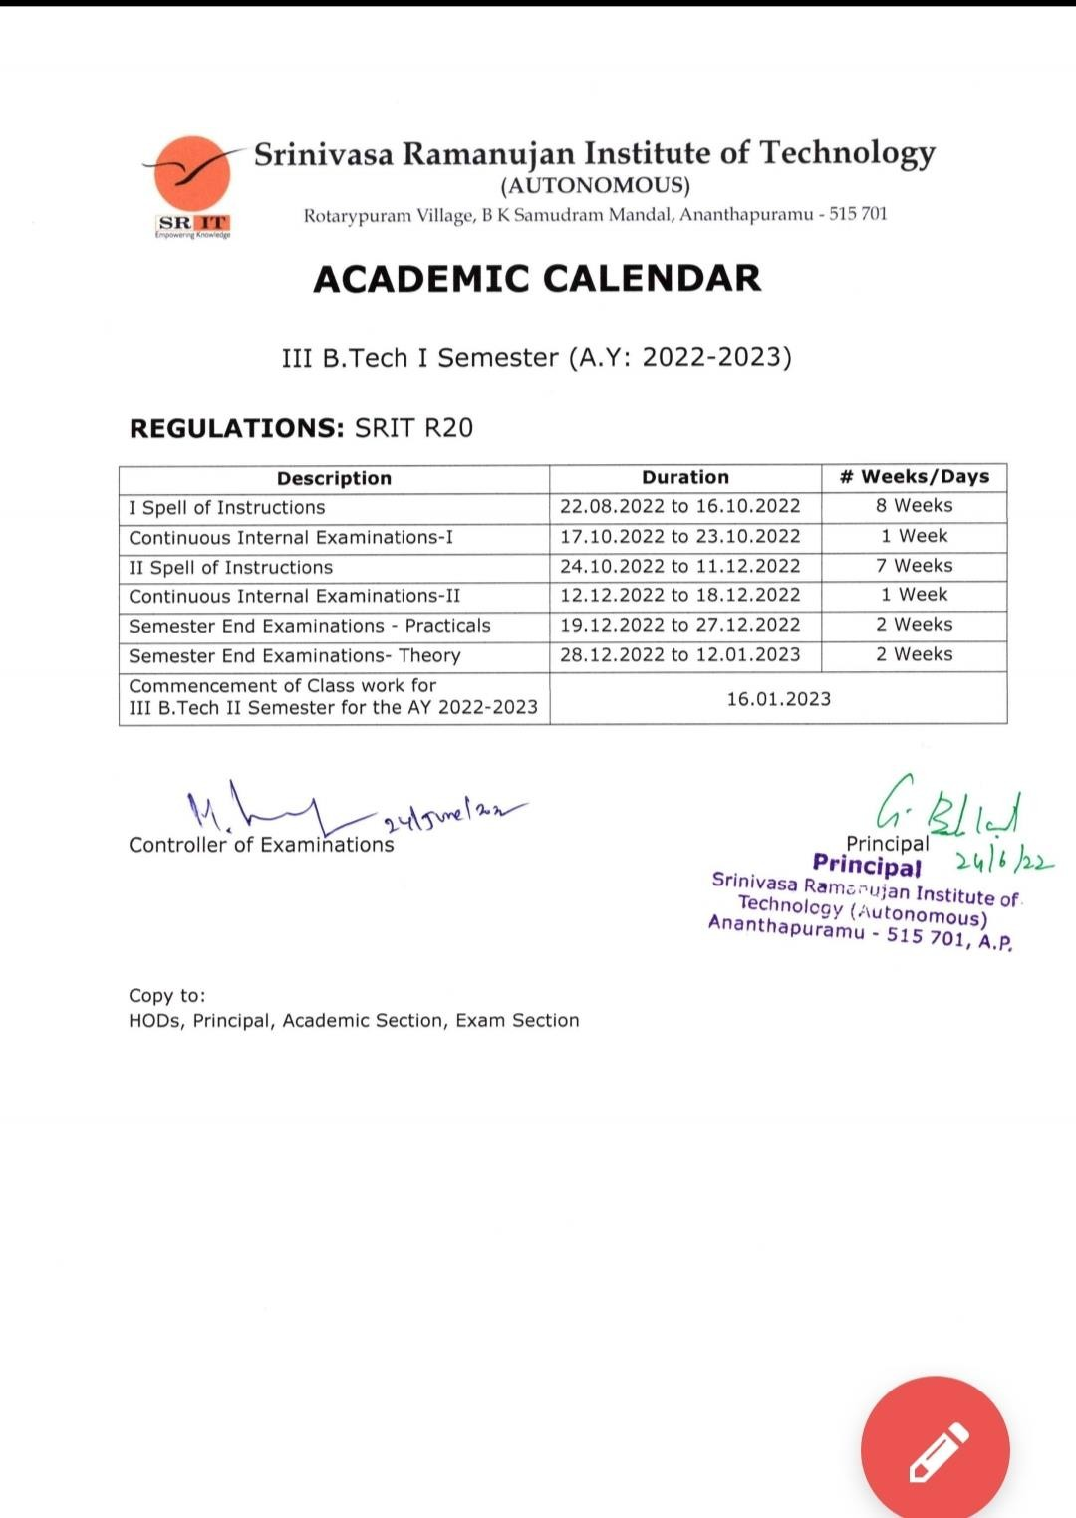

**Mid-1 Question Paper**: **CIE-1**

|  |  |  |  |  |  |  |
| --- | --- | --- | --- | --- | --- | --- |
| **Q. No** | | **Questions** | **Unit** | **Marks** | **CO** | **Cognitive Level** |
| 1 | a) | Define Computer Network. List applications of Computer Networks. | 1 | 2 | CO1 | Remember |
| b) | What are the design issues of Data link layer? | 2 | 2 | CO1 | Remember |
| c) | Compare IP address Vs MAC address | 3 | 2 | CO1 | Remember |
| **UNIT-1** | | | | | | |
| 2 | a) | With a neat sketch, Explain OSI reference model. | | 5 | CO2 | Understand |
| b) | Distinguish among LAN, WAN,MAN. | | 3 | CO2 | Understand |
| **OR** | | | | | | |
| 3 | a) | Discuss about network topologies. | | 5 | CO2 | Understand |
| b) | Compare datagram switching and virtual circuit switching. | | 3 | CO2 | Understand |
| **UNIT-2** | | | | | | |
| 4 | a) | Explain error detection techniques with an example. | | 5 | CO3 | Apply |
| b) | Discuss sliding window protocols. | | 3 | CO3 | Understand |
| **OR** | | | | | | |
| 5 | a) | With a neat sketch, explain Ethernet with examples. | | 5 | CO3 | Understand |
|  | b) | Discuss ALOHA multiple access protocol. | | 3 | CO3 | Understand |
| **UNIT-3** | | | | | | |
| 6 | a) | Distinguish between TCP & UDP. | | 3 | CO4 | Understand |
| b) | Illustrate shortest path routing algorithm with suitable  example. | | 5 | CO4 | Apply |
| **OR** | | | | | | |
| 7 | a) | Write the differences between IPV4 & IPV6 | | 3 | CO4 | Understand |
|  | b) | Explain the general principles of congestion prevention  polices. | | 5 | CO4 | Understand |

# CAA-1

##### Continuous Alternate Assessment-I

|  |  |  |  |  |  |  |
| --- | --- | --- | --- | --- | --- | --- |
| **Course Title:** | **COMPUTER NETWORKS** | | | | **Course Code:** | **R204GA05502** |
| **Class & Sem:** | **III B.Tech I Sem** | | | | **Regulations:** | **SRIT R20** |
| **Course Structure:** | **Theory** | **Tutorial** | **Lab** | **Credits** | **Core/Elective:** | **Core** |
| **3** | **0** | **0** | **3** |
| **Instructor 1:** | **C.LAKSHMINATHA REDDY** | | |  |  | |

**Assignment Questions: Academic Year: 2022-23**

|  |  |  |  |  |
| --- | --- | --- | --- | --- |
| **Q.**  **No.** | **Questions** | **Marks** | **CO** | **Cognitive Level** |
| Unit-I | | | | |
| **1** | Explain OSI Refernce model | 2 | 1 | Understand |
| **2** | Define computer Network? Explain Transmission media with examples | 2 | 1 | Understand |
| Unit-II | | | | |
| **3** | To solve Error detection and Error correction methods and examples. | 2 | 2 | Apply |
| 4 | Demonstrate Ethernet and wireless LAN with examples | 2 | 2 | Apply |
| Unit-III | | | | |
| **5** | What is Network layer? Explain Routing algorithms | 2 | 3 | Understand |

**Remedial class time table:**

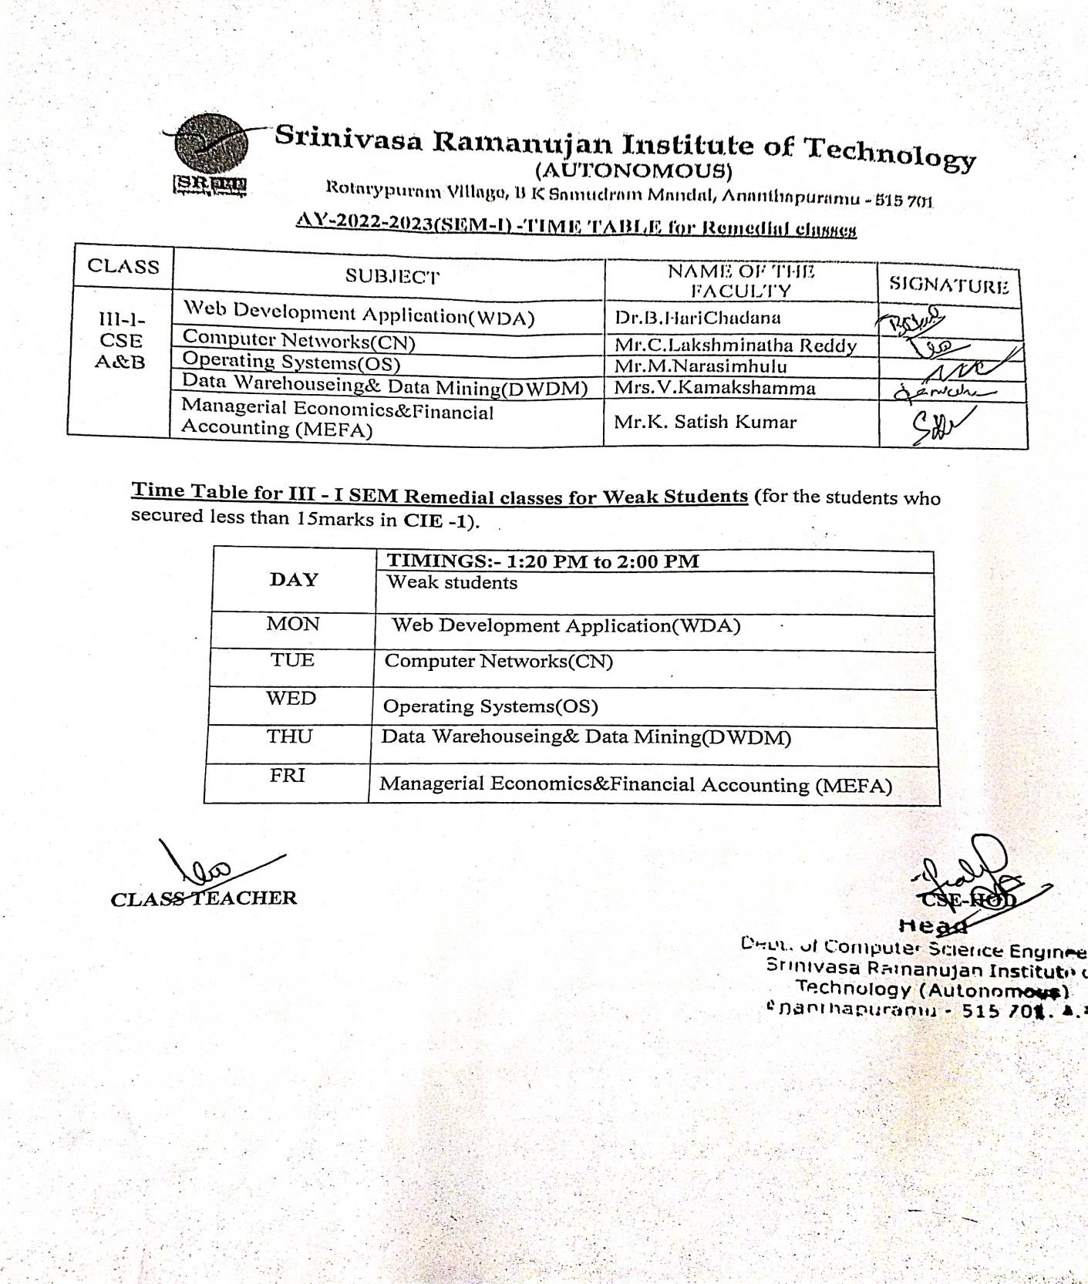

SRINIVASA RAMANUJAN INSTITUTE OF TECHNOLOGY

(Affiliated to JNTUA & Approved by AICTE and Accredited by NAAC with A Grade,Accredited by NBA(ECE,EEE,CSE))

Rotarypuram Village, B K Samudram Mandal, Ananthapuramu - 515701.

Department of Computer Science and Engineering

**Methodology to support weak students & encourage bright students:**

|  |  |  |  |  |  |  |
| --- | --- | --- | --- | --- | --- | --- |
| **Course Title:** | **Computer Networks** | | | | **Course Code:** | **204GA05502** |
| **Class & Sem:** | **III B. Tech I Sem** | | | | **Regulations:** | **R20** |
| **Course Structure:** | **Theory** | **Tutorial** | **Lab** | **Theory** | **Core/Elective** | **Core** |
| **3** | **1** | **-** | **3** |
| **Instructor 1:** | **Mr.Lakshminatha Reddy** | | | | **AY:** | **2022-2023** |

**Methodology to support weak students:**

Student who scored less than 50% of marks in the I internal assessment test will be considered as a slow learner or weak student.

Conducted special classes to improve their academic performance.

**CSE-A & CSE-B:**

|  |  |  |  |
| --- | --- | --- | --- |
| **S.No.** | **Hall Ticket No.** | **Name of the student** | **Mid-1** |
| **1** | **204G1A0527** | **DATTA KOUSHIK.S** | **14** |
| **2** | **204G1A0537** | **HARSHA VARDHAN.T** | **13** |
| **3** | **204G1A0562** | **MUHEETUR RAHMAN T.M.D** | **11** |
| **4** | **204G1A0585** | **SAI HARSHAVARDHAN.N** | **14** |
| **5** | **204G1A0593** | **SARANYA.M** | **14** |
| **6** | **204G1A05A1** | **SREEKAR VAMSI KRISHNA.G** | **12** |
| **7** | **204G1A05A3** | **SRINIVASA SREE SHARAN.A** | **12** |
| **8** | **204G1A05B7** | **VAMSHA VARDHAN REDDY.P** | **11** |
| **9** | **214G5A0508** | **MEHABOOB ARAB KHAN.P** | **13** |
| **10** | **214G5A0509** | **NAGA SIVA RAMAKRISHNA.S** | **14** |

**Course Instructor HOD**

**Course Name: COMPUTER NETWORKS Regulation :R20**

**Year & Sem: III-I CSE A&B AY:2021-22**

**Time Table for Special Classes (for Weak Students):**

|  |  |  |  |
| --- | --- | --- | --- |
| S. No | Date | Time | Topics Discussed |
| UNIT-1 | | | |
| 1 | 08-11-2022 | 1:20 - 2:00 | OSI Reference model |
| Transmission media |
| TCP/IP layers |
| Network topologies |
| Circuit switching, Packet switching. |
| UNIT-2 | | | |
| 2 | 15-11-2022 | 1:20 - 2:00 | Design issues Data link layer |
| Error correction & detection techniques |
| MAC |
| Ethernet ,slide window protocol |
| Wireless LAN |
| UNIT-3 | | | |
| 3 | 22-11-2022 | 1:20 - 2:00 | Congestion control algorithm |
| TCP & UDP |
| IPV4 & IPV6 format. |
| Transport layer services |
| Leak bucket algorithm |
| IP header format |
| UNIT-4 | | | |
| 4 | 29-11-2022 | 1:20 - 2:00 | DNS |
| FTP |
| WWW & HTTP |
| E-mail |
| TELNET |
| SNMP |
| UNIT-5 | | | |
| 5 | 06-12-2022 | 1:20 - 2:00 | Cryptography – encryption,descryption |
| AES,DES algorithm |
| RSA algorithm |
| Digital signature algorithm |
| E-mail security issues |

**Course Instructor HOD**

**Course Name: COMPUTER NETWORKS Regulation :R20 Year & Sem: III-I CSE A&B AY:2022-23**

**Attendance for Special Classes:**

|  |  |  |  |  |
| --- | --- | --- | --- | --- |
| **S.No.** | **Hall Ticket**  **No.** | **Name of the student** | **No. of special**  **classes conducted** | **No. of special**  **classes attended** |
| **1** | **204G1A0527** | **DATTA KOUSHIK.S** | 5 | 4 |
| **2** | **204G1A0537** | **HARSHA VARDHAN.T** | 5 | 3 |
| **3** | **204G1A0562** | **MUHEETUR RAHMAN T.M.D** | 5 | 4 |
| **4** | **204G1A0585** | **SAI HARSHAVARDHAN.N** | 5 | 3 |
| **5** | **204G1A0593** | **SARANYA.M** | 5 | 4 |
| **6** | **204G1A05A1** | **SREEKAR VAMSI KRISHNA.G** | 5 | 4 |
| **7** | **204G1A05A3** | **SRINIVASA SREE SHARAN.A** | 5 | 4 |
| **8** | **204G1A05B7** | **VAMSHA VARDHAN REDDY.P** | 5 | 4 |
| **9** | **214G5A0508** | **MEHABOOB ARAB KHAN.P** | 5 | 3 |
| **10** | **214G5A0509** | **NAGA SIVA RAMAKRISHNA.S** | 5 | 4 |

**Course Instructor HOD**

# CIE-2

|  |  |  |  |  |  |  |
| --- | --- | --- | --- | --- | --- | --- |
| **Q.**  **No** | **Questions** | | **Unit** | **Marks** | **CO** | **Cognitive Level** |
| 1 | a) | Describe transport layer protocols. | 3 | 2 | CO1 | Remember |
| b) | What are the services are http protocol? | 4 | 2 | CO1 | Remember |
| c) | Compare Symmetric key and Asymmetric key. | 5 | 2 | CO1 | Remember |
| **UNIT-III** | | | | | | |
| 2 | a) Discuss transport layer, transport services. | | | 5 | CO4 | Understand |
| b) Explain elements of transport protocols. | | | 3 | CO4 | Understand |
| **OR** | | | | | | |
| 3 | a) | Discuss TCP and UDP format with example. | | 3 | CO4 | Understand |
| b) | Explain Congestion control with example. | | 5 | CO4 | Understand |
| **UNIT-IV** | | | | | | |
| 4 | a)Explain file transport protocol with example. | | | 5 | CO5 | Understand |
|  | b) Describe simple network management protocol. | | | 3 | CO5 | Understand |
| **OR** | | | | | | |
| 5 | a)Explain DNS types with example structure. | | | 5 | CO5 | Understand |
|  | b) Describe WWW and HTTP. | | | 3 | CO5 | Understand |
| **UNIT-V** | | | | | | |
| 6 | a) | Illustrate RSA algorithm two prime members p=3,q=5. | | 5 | CO6 | Apply |
| b) | Compare Asymmetric algorithm and Symmetric algorithm. | | 3 | CO6 | Understand |
| **OR** | | | | | | |
| 7 | a)Explain digital signature algorthim with example. | | | 5 | CO6 | Understand |
|  | b)Describe conversion of encryption and decryption. | | | 3 | CO6 | Understand |

**CAA-2**

##### Continuous Alternate Assessment-II

|  |  |  |  |  |  |  |
| --- | --- | --- | --- | --- | --- | --- |
| **Course Title:** | **COMPUTER NETWORKS** | | | | **Course Code:** | **R204GA05502** |
| **Class & Sem:** | **III B.Tech I Sem** | | | | **Regulations:** | **SRIT R20** |
| **Course Structure:** | **Theory** | **Tutorial** | **Lab** | **Credits** | **Core/Elective:** | **Core** |
| **3** | **0** | **0** | **3** |
| **Instructor 1:** | **C.LAKSHMINATHA REDDY** | | |  |  | |

**Assignment Questions: Academic Year: 2022-23**

|  |  |  |  |  |
| --- | --- | --- | --- | --- |
| **Q.**  **No.** | **Questions** | **Marks** | **CO** | **Cognitive Level** |
| Unit-III | | | | |
| **1** | Explain Congestion Control in Transport layer | 2 | 4 | Understand |
| Unit-IV | | | | |
| **2** | Explain DNS with examples | 2 | 5 | Understand |
| 3 | Explain Electronic – mail in Application layer | 2 | 5 | Understand |
| Unit-V | | | | |
| **4** | Define Cryptography ? Explain AES,DES algorthim with example | 2 | 6 | Understand |
| **5** | Explain Digital Signature with example | 2 | 6 | Understand |

**Course Name: COMPUTER NETWORKS Regulation :R20 Year & Sem: III-I CSE A&B AY:2022-23**

**Special Classes – Improvement Analysis:**

|  |  |  |  |  |
| --- | --- | --- | --- | --- |
| **S.No.** | **Hall Ticket No.** | **Name of the student** | **Mid-1** | **Mid-2** |
| **1** | **204G1A0527** | **DATTA KOUSHIK.S** | **14** | **13** |
| **2** | **204G1A0537** | **HARSHA VARDHAN.T** | **13** | **11** |
| **4** | **204G1A0585** | **SAI HARSHAVARDHAN.N** | **14** | **23** |
| **5** | **204G1A0593** | **SARANYA.M** | **14** | **22** |
| **6** | **204G1A05A1** | **SREEKAR VAMSI KRISHNA.G** | **12** | **17** |
| **7** | **204G1A05A3** | **SRINIVASA SREE SHARAN.A** | **12** | **17** |
| **8** | **204G1A05B7** | **VAMSHA VARDHAN REDDY.P** | **11** | **16** |
| **9** | **214G5A0508** | **MEHABOOB ARAB KHAN.P** | **13** | **17** |
| **10** | **214G5A0509** | **NAGA SIVA RAMAKRISHNA.S** | **14** | **18** |

**Course Instructor HOD**

SRINIVASA RAMANUJAN INSTITUTE OF TECHNOLOGY

(Affiliated to JNTUA & Approved by AICTE and Accredited by NAAC with A Grade,Accredited by NBA(ECE,EEE,CSE))

Rotarypuram Village, B K Samudram Mandal, Ananthapuramu - 515701.

Department of Computer Science and Engineering

**Methodology to support weak students & encourage bright students:**

|  |  |  |  |  |  |  |
| --- | --- | --- | --- | --- | --- | --- |
| **Course Title:** | **Computer networks** | | | | **Course Code:** |  |
| **Class & Sem:** | **III B. Tech I Sem** | | | | **Regulations:** | **R20** |
| **Course Structure:** | **Theory** | **Tutorial** | **Lab** | **Theory** | **Core/Elective** | **Core**  **-** |
| **3** | **1** | **-** | **3** |
| **Instructor 1:** | **Mr.Lakshminatha Reddy** | | | | **AY:** | **2021-2022** |

**Methodology to encourage bright students:**

Student who scored more than 50% of marks in the I internal assessment test will be considered as a bright student. Conducted GATE orientation classes student.

**CSE-A & CSE-B:**

**GATE online video links:**

[**https://youtube.com/watch?v=GFywKHYCKNk&si=EnSIkaIECMiOmarE**](https://youtube.com/watch?v=GFywKHYCKNk&si=EnSIkaIECMiOmarE)

[**https://youtube.com/watch?v=6gDQfr7zSzw&si=EnSIkaIECMiOmarE**](https://youtube.com/watch?v=6gDQfr7zSzw&si=EnSIkaIECMiOmarE)[**https://youtube.com/watch?v=i0vNXIgu2O8&si=EnSIkaIECMiOmarE**](https://youtube.com/watch?v=i0vNXIgu2O8&si=EnSIkaIECMiOmarE)[**https://youtube.com/watch?v=x4n\_Auta4sI&si=EnSIkaIECMiOmarE**](https://youtube.com/watch?v=x4n_Auta4sI&si=EnSIkaIECMiOmarE)

**Course Instructor HOD**

# Question Bank-Unit wise

#### SRINIVASA RAMANUJAN INSTITUTE OF TECHNOLOGY

**(AUTONOMOUS)**

III B. Tech I Sem – Question Bank **COMPUTER NETWROKS [204GA05502]**

**(**Computer Science & Engineering)

|  |  |  |
| --- | --- | --- |
| **CO** | **COURSE OUTCOMES** | **BL** |
| CO1 | Demonstrate the different building blocks of Communication network and its architecture. | U |
| CO2 | Choose different types of networks and calculate the performance of network. | A |
| CO3 | Identify and examine design issues of Data Link Layer. | A |
| CO4 | Compare and Contrast various types of Routing Algorithms and Congestion Control Algorithms. | A |
| CO5 | Demonstrate fundamentals of transport services, protocols, and congestion control Algorithms and its performance. | An |
| CO6 | Make use of fundamental applications of Application Layer and its Security mechanisms | A |

**\**Note:*** *1.Remeber(****R****), 2.Understand (****U****), 3. Apply (****A****) 4. Analyze (****An****), 5. Evaluate (****E****), 6. Create(****C****)*

**\*\*\***

|  |  |  |  |
| --- | --- | --- | --- |
| **UNIT – 1 (2 Marks)** | | | |
| **#** | **Questions** | **CO** | **BL** |
| 1 | Define Computer Network. List applications of Computer Networks. | CO1 | R |
| 2 | What do you mean by computer network? List any two applications of computer networks. | CO1 | R |
| 3 | Define topology? List its types. | CO1 | R |
| 4 | Differentiate between internet and Intranet. | CO1 | R |
| 5 | What is Transmission impairment? | CO2 | R |

|  |  |  |  |
| --- | --- | --- | --- |
| 6 | Write the different types of networks. | CO1 | R |
| 7  8  9 | Write the different types of Transmission media. Define switching?  Write the differences between Data and Signals. | CO2 CO2 CO2 | R R R |
| 10 | List the layers in OSI reference model. | CO1 | R |
| 11 | List the layers in TCP/IP reference model. | CO1 | R |
| 12 | List out the advantages and disadvantages of circuit switching. | CO2 | R |
| 13 | A network with bandwidth of 10 Mbps can pass only an average of 12,000 frames per minute with each frame carrying an average of 10,000 bits. What is the throughput of this network? | CO2 | A |

|  |  |  |  |
| --- | --- | --- | --- |
| 14 | Differentiate between guided and unguided transmission media | CO2 | R |

|  |  |  |  |  |
| --- | --- | --- | --- | --- |
| 15 | What is Attenuation? | | CO2 | R |
| **UNIT-1 (5 Marks)** | | | | |
| **#** | **Questions** | **M** | **CO** | **BL** |
| 1 | Define computer networks. Explain its types. | 5 | CO1 | U |
| 2 | Explain the significance of Switching? What are different switching techniques used in computer networks? Discuss with a neat sketch. | 10 | CO2 | U |
| 3 | Explain Layers in TCP/IP model. | 10 | CO1 | U |
| 4 | Explain the different topologies of the network. | 10 | CO1 | U |
| 5 | Explain the principal differences between connection-oriented communication and connectionless communication. | 5 | CO1 | U |
| 6 | Define transmission medium. Explain different transmission medium with their advantages and disadvantages. | 10 | CO2 | U |
| 7 | State the purpose of layering in networks. Explain different layers of OSI referential model with their functionality. | 10 | CO1 | U |

|  |  |  |  |  |
| --- | --- | --- | --- | --- |
| 8 | What do you mean by Protocol layering? Explain layered network architecture. | 5 | CO2 | U |
| 9 | Compare Datagram switching Vs Virtual circuit switching. | 5 | CO2 | U |
| 10 | With neat sketch explain Twisted pair cables, connectors of twisted pair cables with neat graph explain the performance of Twisted pair cables | 10 | CO2 | U |
| 11 | Differentiate OSI reference model with the TCP/IP reference model. | 5 | CO1 | U |
| 12 | Describe briefly about the circuit-switched networks. | 5 | CO2 | U |
| 13 | What do you mean by computer network? Classify computer networks and explain them in brief. | 10 | CO1 | U |
| 14 | Why twisted pair cables are preferable over coaxial cables? Explain | 5 | CO2 | U |
| 15 | Explain detail about Network Hardware. How network hardware supports the communication of two systems? | 10 | CO1 | U |



**# Questions M CO BL**

|  |  |  |  |
| --- | --- | --- | --- |
| **UNIT – 2 (2 Marks)** | | | |
| **#** | **Questions** | **CO** | **BL** |
| 1 | A bit string 0111101111101111110, needs to be transmitted at the data link layer. What is the string actually transmitted after bit stuffing? | CO3 | U |
| 2 | What are the responsibilities of data link layer? | CO3 | R |
| 3 | List the design issues of data link layer? | CO3 | R |
| 4 | What is mean by error control? | CO3 | R |
| 5 | What are the functions of MAC? | CO3 | R |
| 6 | Identify the class and default subnet mask of the IP address 217.65.10.7 | CO3 | U |
| 7 | What is Piggybacking. | CO3 | R |
| 8 | What is an error? Write the types of errors. | CO3 | R |
| 9 | What are the two sublayers of Data link layer? | CO3 | R |
| 10 List various framing methods in datalink layer.  **UNIT – 2 (5/10 Marks)** | | | |

|  |  |  |  |  |
| --- | --- | --- | --- | --- |
| 1 | What are the design issues of Data Link Layer? Explain | 5 | CO3 | U |

|  |  |  |  |  |
| --- | --- | --- | --- | --- |
| 2 | Describe CSMA/CD protocol in Ethernet. | 10 | CO3 | U |

|  |  |  |  |
| --- | --- | --- | --- |
| **UNIT – 3 (2 Marks)** | | | |
| **#** | **Questions** | **CO** | **BL** |
| 1 | Define Congestion. | CO4 | R |
| 2 | Differentiate the open loop congestion control and closed loop congestion control. | CO5 | U |

|  |  |  |  |  |
| --- | --- | --- | --- | --- |
| 3 | Explain in detail about the Simplex Stop and Wait protocol. | 5 | CO3 | U |
| 4 | Explain about ALOHA and CDMA protocols. | 10 | CO3 | U |
| 5 | With neat sketch explain the Elementary data link layer Protocols. | 10 | CO3 | U |
| 6 | With an example explain the sliding window Flow control mechanism. | 5 | CO3 | U |
| 7 | What is the need of Flow control? Explain the common approaches for flow control in data link layer | 10 | CO3 | U |
| 8 | Explain how slotted ALOHA solves the problem of Channel allocation. | 5 | CO3 | U |
| 9 | What are the various types of error detection methods? Explain. | 10 | CO3 | U |
| 10 | Explain about the carrier sense multiple access protocols. | 5 | CO3 | U |
| 11 | Describe the working principle of Carrier sense multiple access with collision Detection (CSMA/CD). | 5 | CO3 | U |
| 12 | What are the draw backs of stop and wait protocol? How can they overcome by sliding window protocol | 5 | CO3 | U |
| 13 | Explain Go-Back- N ARQ protocol with an example. | 5 | CO3 | A |
| 14 | Briefly explain about Wireless LAN. | 5 | CO3 | U |
| 15 | Discuss about Ethernet. | 5 | CO3 | U |
| 16 | Briefly explain about the framing methods in datalink layer. | 10 | CO3 | U |
| 17 | With an example, Explain the following error detection techniques i) Cheksum ii) CRC | 10 | CO3 | A |



|  |  |  |  |  |
| --- | --- | --- | --- | --- |
| 3 | What are the responsibilities of Network Layer? | | CO4 | R |
| 4 | Define internetwork. | | CO4 | R |
| 5 | What are the types of class full addressing? | | CO4 | R |
| 6 | Define subnetting. | | CO4 | R |
| 7 | What is routing? | | CO4 | R |
| 8 | What are the salient features of IPv6? | | CO4 | R |
| 9 | What are the advantages of using UDP over TCP? | | CO5 | U |
| 10  11 | What is TCP?  What do you mean by QoS? | | CO5 CO5 | R R |
| 12  13 | What is a port?  What are the functions of transport layer? | | CO5 CO5 | R R |
| 14  15 | List the three types of addresses in TCP/IP. Define jitter. | | CO5 CO5 | R R |
| **UNIT – 3 (5/10 Marks)** | | | | |
| **#** | **Questions** | **M** | **CO** | **BL** |

|  |  |  |  |  |
| --- | --- | --- | --- | --- |
| 1 | Give the format of TCP header and discuss the relevance of various fields. | 10 | CO5 | U |

|  |  |  |  |  |
| --- | --- | --- | --- | --- |
| 2 | How transport layer connection is established in TCP? Illustrate with state diagrams. | 10 | CO5 | A |
| 3 | Illustrate shortest path routing algorithm with suitable example. | 10 | CO4 | A |
| 4 | Explain the general principles of congestion prevention policies. | 5 | CO4 | U |
| 5 | Draw and explain the header format for a user datagram protocol. | 5 | CO5 | U |
| 6 | What is the format of IPv4 header? Describe the significance of each field. | 10 | CO4 | U |
| 7 | Explain the Real Time Transport Protocol. | 5 | CO5 | U |
| 8 | Discuss in detail about the connection establishment and release in TCP. | 10 | CO5 | U |
| 9 | With an example explain the any one Dynamic routing algorithm used in computer networks. | 10 | CO4 | A |

|  |  |  |  |  |
| --- | --- | --- | --- | --- |
| 10 | Explain the Services of Transport layer. | 5 | CO5 | U |
| 11 | Explain leaky bucket and token bucket algorithms. | 10 | CO5 | U |
| 12 | With an example explain the distance vector routing algorithms used in computer networks | 10 | CO4 | A |
| 14 | With an example explain the Flooding, Hierarchical routing algorithms used in computer networks. | 10 | CO4 | U |
| 15 | Draw and explain each field in the TCP Segment header. | 5 | CO5 | U |
| 16 | Classify the static and dynamic routing algorithms? Explain the basic concept of flooding. | 10 | CO4 | U |
| 17 | How does UDP differ from TCP? List the applications of UDP. | 5 | CO5 | U |
| 18 | Distinguish between Leaky Bucket algorithm and Token Bucket algorithm. | 5 | CO5 | U |
| 19 | Explain in detail three-way handshaking for connection establishment in TCP. | 10 | CO5 | U |
| 20 | What are the static routing algorithms? Explain the concept of flooding. | 5 | CO4 | U |
| 21 | What are the functions of transport layer? State transport service primitives | 5 | CO5 | U |
| 22 | Discuss various flow control mechanisms in transport layer | 10 | CO5 | U |
| 23 | Explain the link-state routing protocol with an example. | 10 | CO4 | U |

\*\*\*

|  |  |  |  |
| --- | --- | --- | --- |
| **UNIT – 4 (2 Marks)** | | | |
| **#** | **Questions** | **CO** | **BL** |
| 1 | What is DNS? | CO6 | R |
| 2 | What is SMTP? | CO6 | R |
| 3 | What is the goal of Domain name system? | CO6 | R |
| 4 | List the basic functions of email. | CO6 | R |
| 5 | What is web browser? | CO6 | R |
| 6 | What do you mean by TELNET? | CO6 | R |
| 7 | Write the responsibilities of Application Layer? | CO6 | R |

|  |  |  |  |
| --- | --- | --- | --- |
| 8 | Write down the three types of WWW documents. | CO6 | R |

|  |  |  |  |
| --- | --- | --- | --- |
| 9 | What is fully Qualified Domain Name? | CO6 | R |

|  |  |  |  |  |
| --- | --- | --- | --- | --- |
| 10 | What are the two types of connections in FTP? | | CO6 | R |
| 11 | What are the components of a browser? | | CO6 | R |
| 12 | What is POP? | | CO6 | R |
| **UNIT – 4 (5/10 Marks)** | | | | |
| **#** | **Questions** | **M** | **CO** | **BL** |
| 1 | Write about electronic mail in detail. | 10 | CO6 | U |
| 2 | Explain the working of DNS. | 10 | CO6 | U |
| 3 | What is DNS? What resource records are associated with it? Explain. | 10 | CO6 | U |
| 4 | What are the five basic functions supported in e-mail systems? Explain. | 5 | CO6 | U |
| 5 | Define FTP. Discuss in brief about FTP. | 10 | CO6 | U |
| 6 | What is electronic E-mail? Describe in brief about the architecture of email. | 10 | CO6 | U |
| 7 | Explain in brief about the formats of HTTP request and Response messages? | 5 | CO6 | U |
| 8 | What is World Wide Web? Explain details about HTTP. | 10 | CO6 | U |
| 9 | Describe importance of DNS in application layer. | 5 | CO6 | U |
| 10 | How DNS service maps domain names to IP addresses? Explain with an example. | 10 | CO6 | U |
| 11 | What is a URL and explain about its components? | 5 | CO6 | U |
| 12 | Explain the functions of Network Management Systems. | 5 | CO6 | U |
| 13 | Discuss in detail about SNMP. | 10 | CO6 | U |

\*\*\*

|  |  |  |  |
| --- | --- | --- | --- |
| **UNIT – 5 (2 Marks)** | | | |
| **#** | **Questions** | **CO** | **BL** |

|  |  |  |  |
| --- | --- | --- | --- |
| 1 | Distinguish between symmetric and asymmetric encryption. | CO6 | U |
| 2 | What is meant by substitution ciphers? | CO6 | R |
| 3 | What is meant by Transposition ciphers? | CO6 | R |
| 4 | Define cipher. | CO6 | R |
| 5 | Differentiate between symmetric and asymmetric key algorithms. | CO6 | U |
| 6 | What are the two basic methods used in encryption algorithms? | CO6 | R |
| 7 | List out the components of encryption algorithm. | CO6 | R |
| 8 | Distinguish between symmetric and asymmetric encryption. | CO6 | R |
| 9 | What is meant by substitution ciphers? | CO6 | R |
| 10  11 | What is meant by Transposition ciphers? Define cipher. | CO6 CO6 | R R |
| 12  13 | Write down the purpose of S-Boxes in DES? What are disadvantages of double DES? | CO6 CO6 | R R |
| 14  16 | Brief the strength of triple DES.  What is cryptanalysis and cryptography? | CO6 CO6 | R R |

|  |  |  |  |  |
| --- | --- | --- | --- | --- |
| **UNIT – 5 (5/10 Marks)** | | | | |
| **#** | **Questions** | **M** | **CO** | **BL** |
| 1 | Compare Substitution and Transposition techniques. | 5 | CO6 | U |
| 2 | Differentiate symmetric and asymmetric encryption. | 5 | CO6 | U |
| 3 | What are the different modes of operation in DES? Explain. | 10 | CO6 | U |
| 4 | What is the difference between diffusion and confusion? | 5 | CO6 | U |
| 5 | What are the operations used in AES? Explain. | 10 | CO6 | U |
| 6 | Difference between private key and public key algorithm | 5 | CO6 | U |
| 7 | Explain in detail about DES and Triple DES | 10 | CO6 | U |
| 8 | Explain about AES in detail. | 10 | CO6 | U |

|  |  |  |  |  |
| --- | --- | --- | --- | --- |
| 9 | Explain the RSA algorithm and explain the RSA with p=7,q=11,e=17,M=8. Discuss its merits. | 10 | CO6 | A |
| 10 | Explain in detail about RSA. | 10 | CO6 | U |
| 11 | How does simple columnar transposition work? Explain with an example. | 10 | CO6 | U |

**Course Internal Marks: (CIE1,CAA1,CIE2,CAA2):**

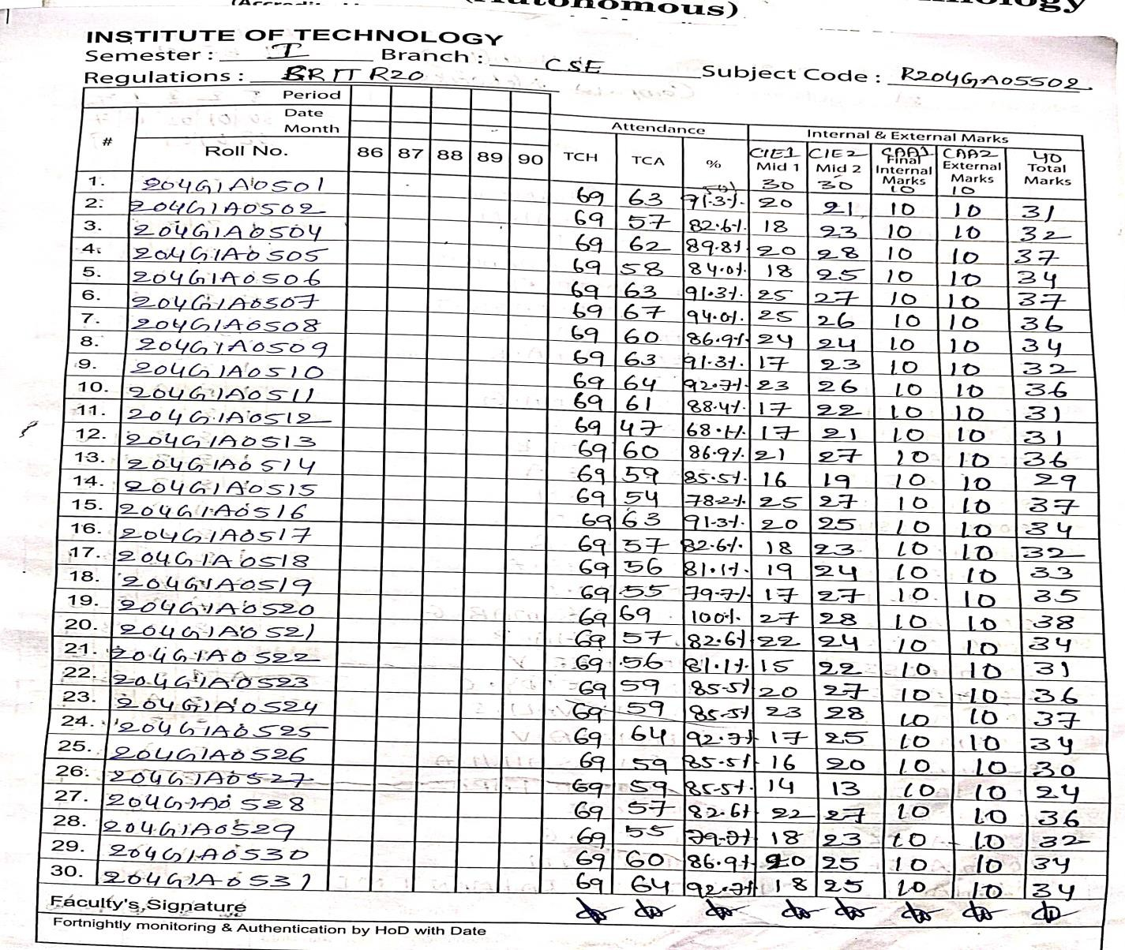

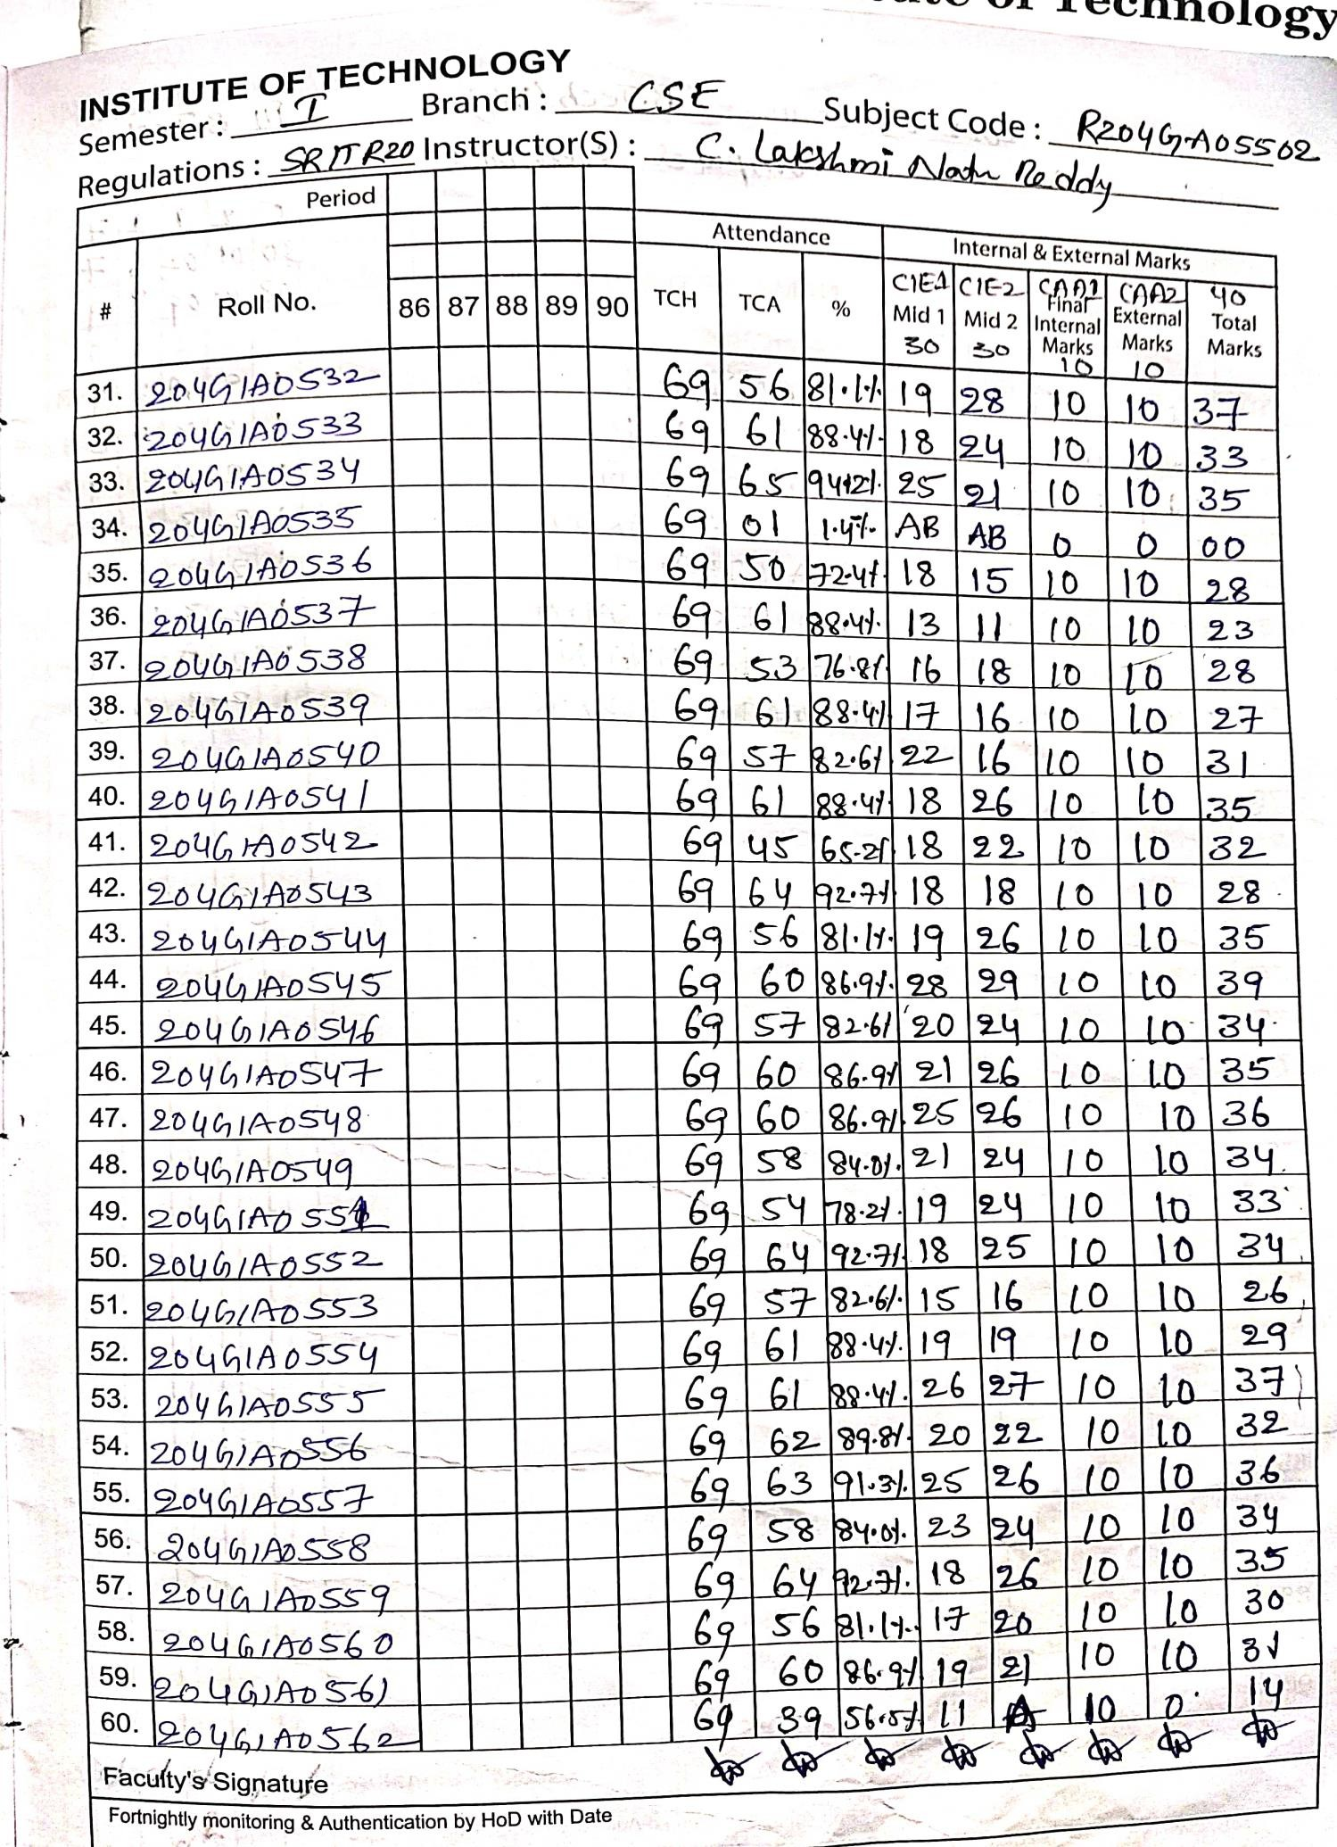

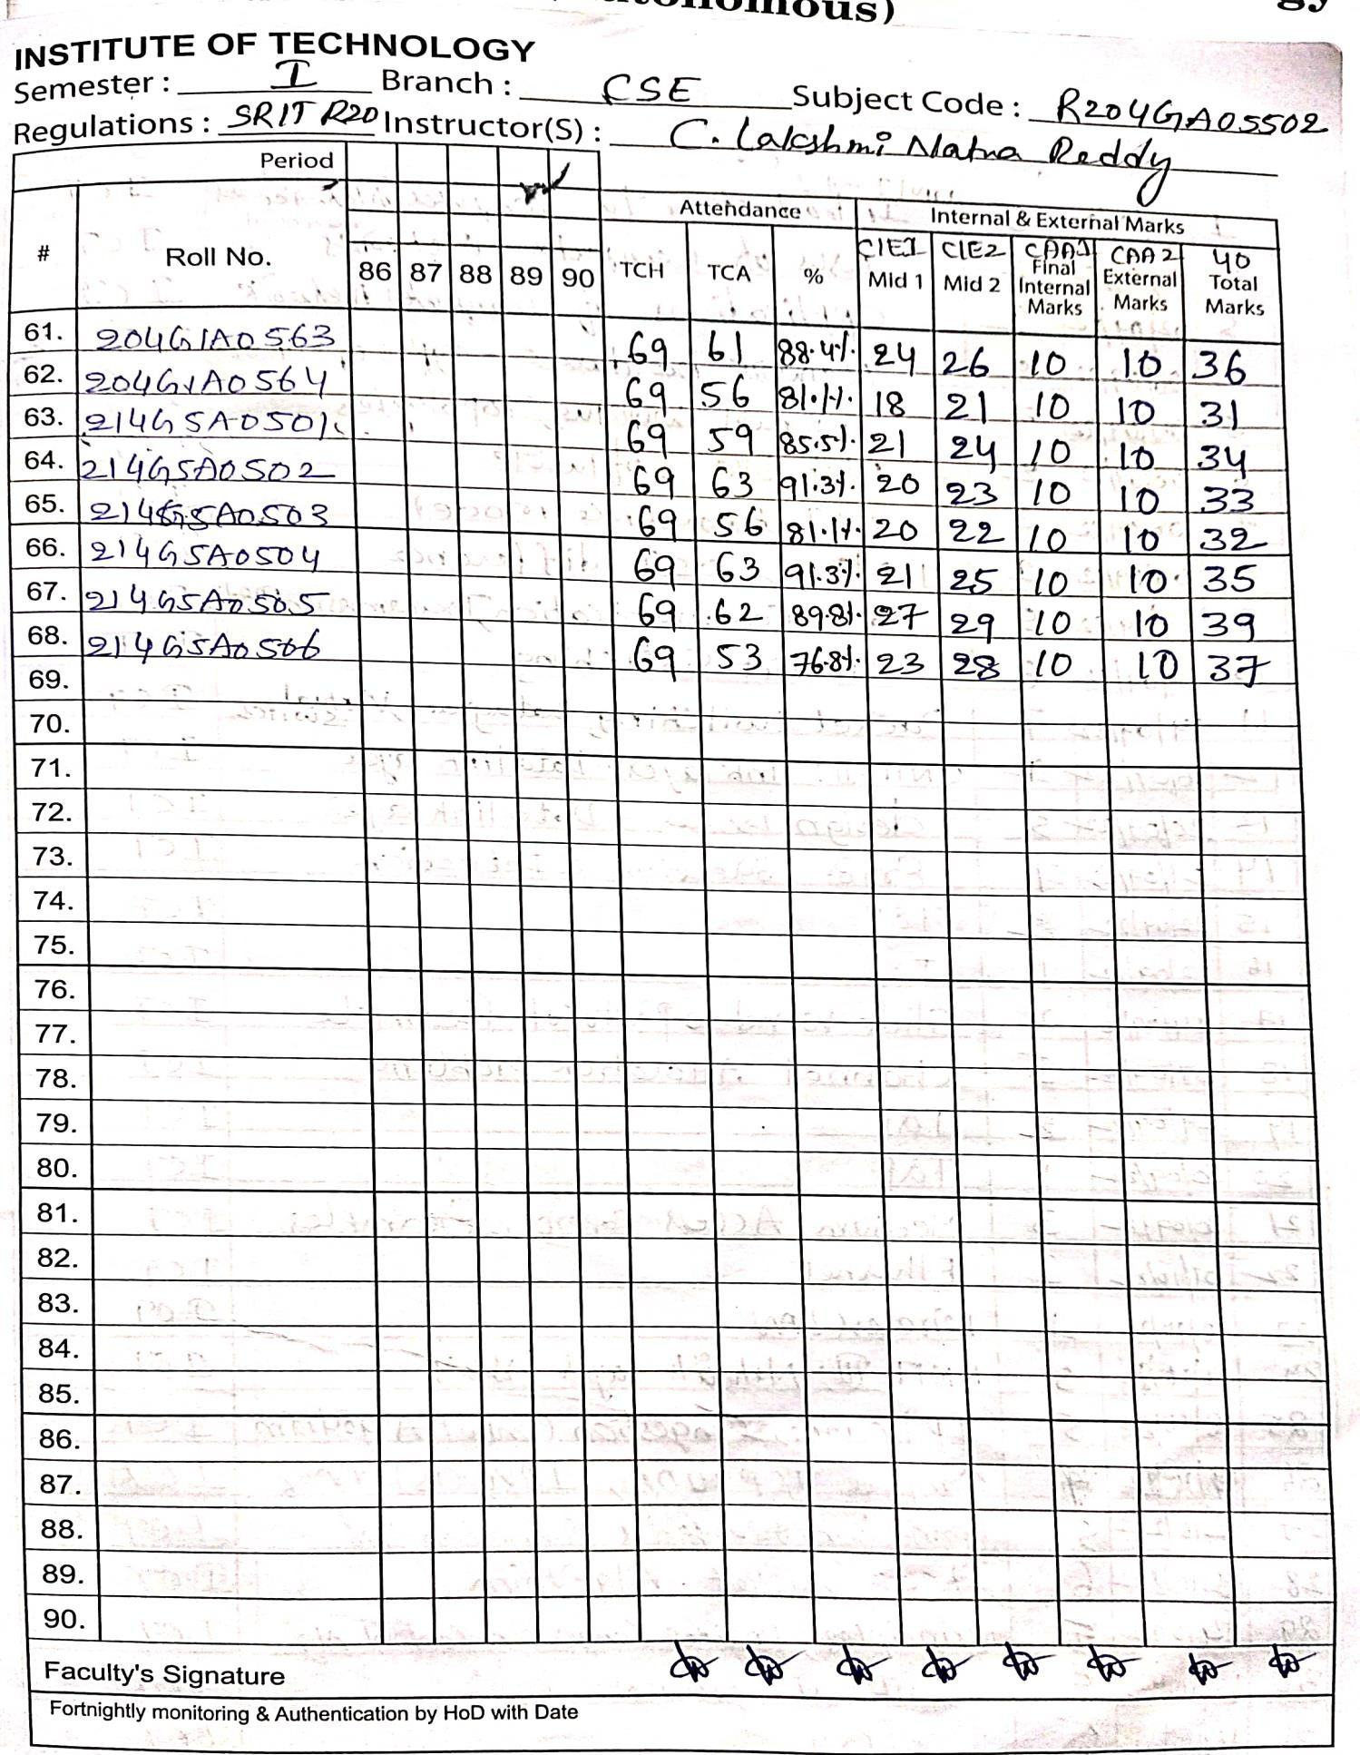

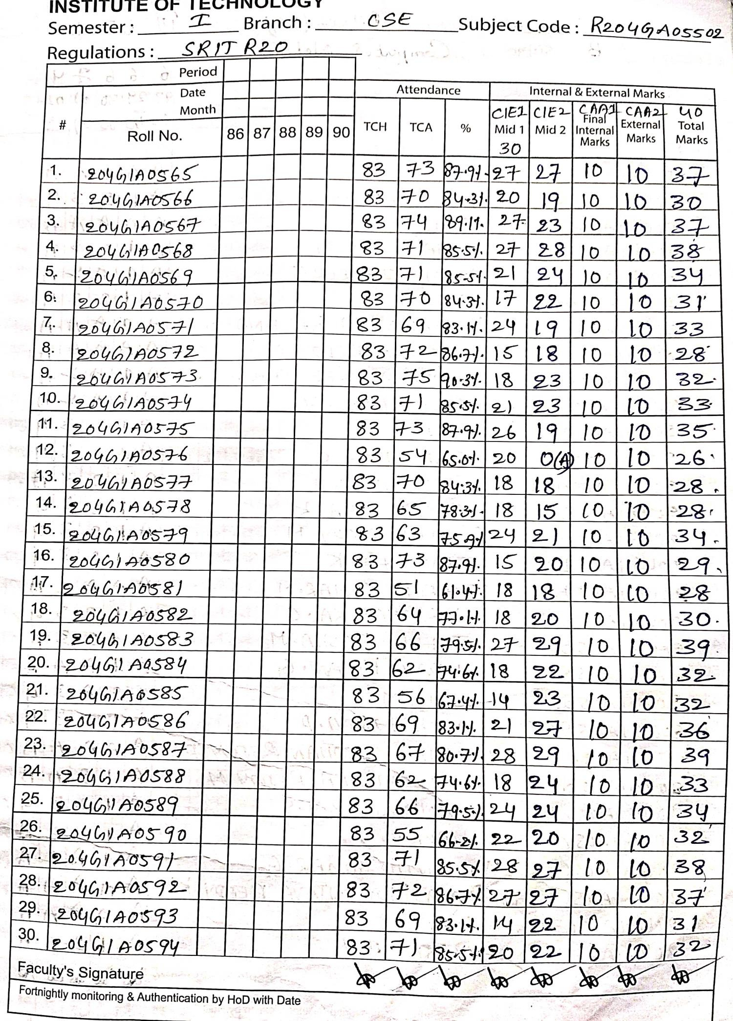

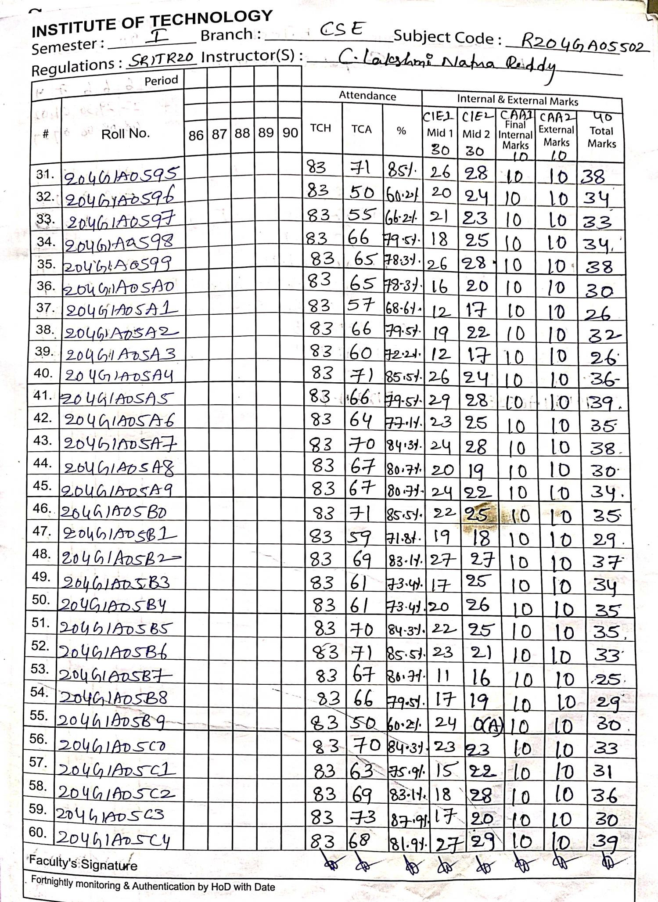

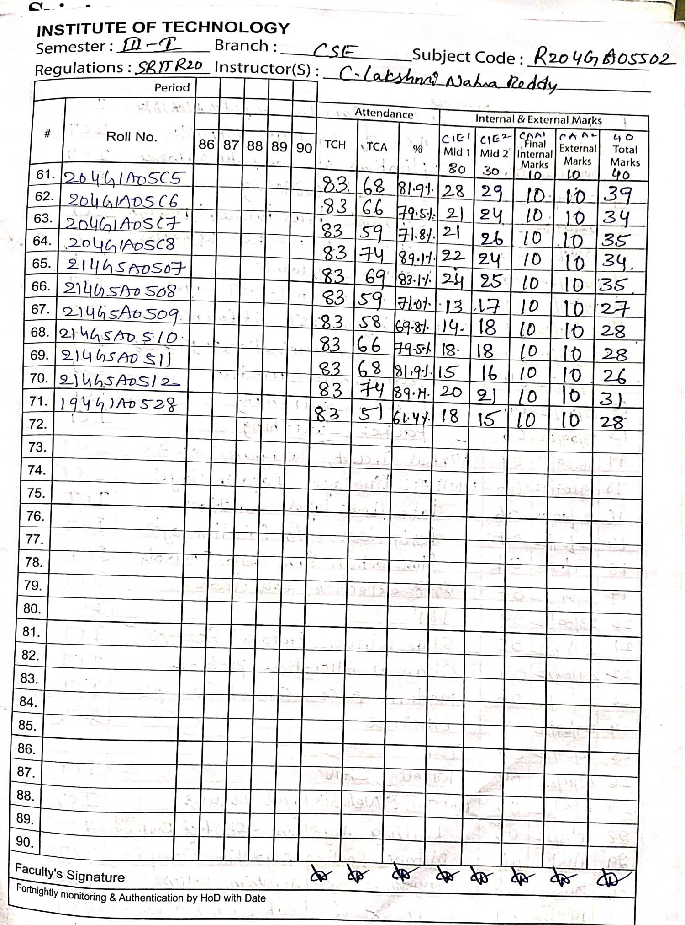

**Course Google Class Room links :** [**https://classroom.google.com/c/NDk3NTkzMDA1MDAy?cjc=yx6eqwv**](https://classroom.google.com/c/NDk3NTkzMDA1MDAy?cjc=yx6eqwv)[**https://classroom.google.com/c/NTM4ODA5MDg2NjY3?cjc=qetcely**](https://classroom.google.com/c/NTM4ODA5MDg2NjY3?cjc=qetcely)

**Previous year Question papers:**

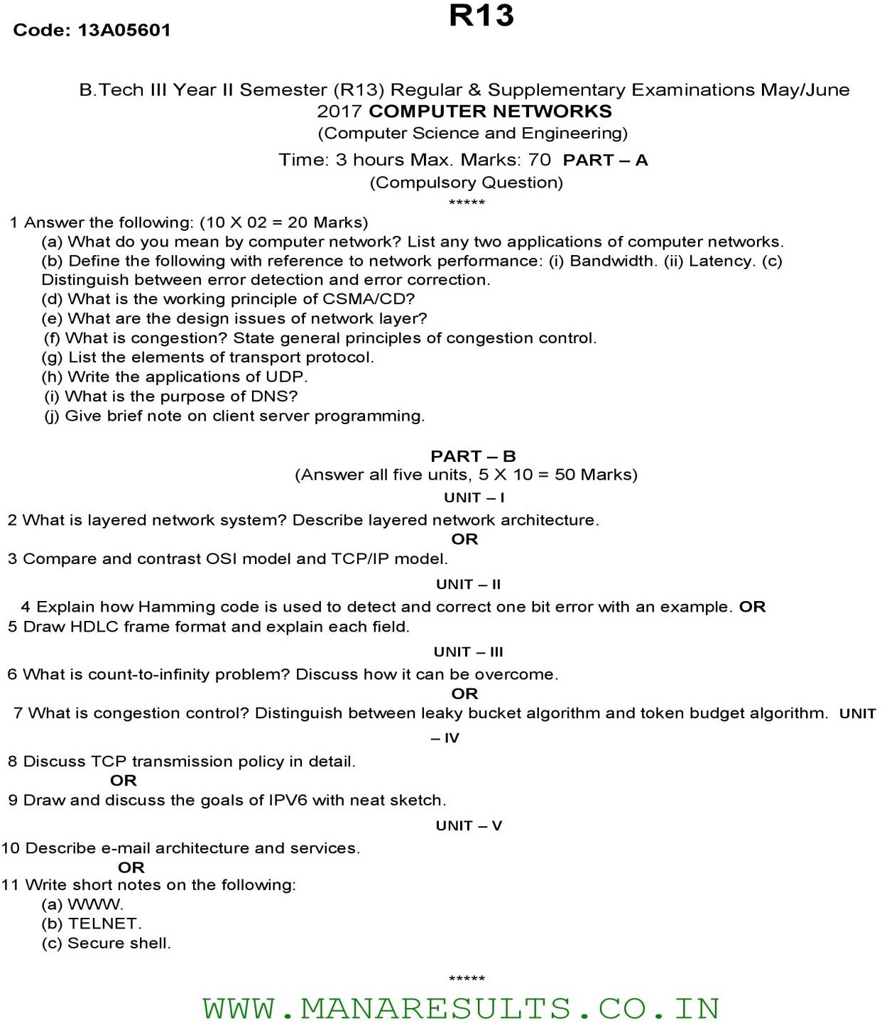

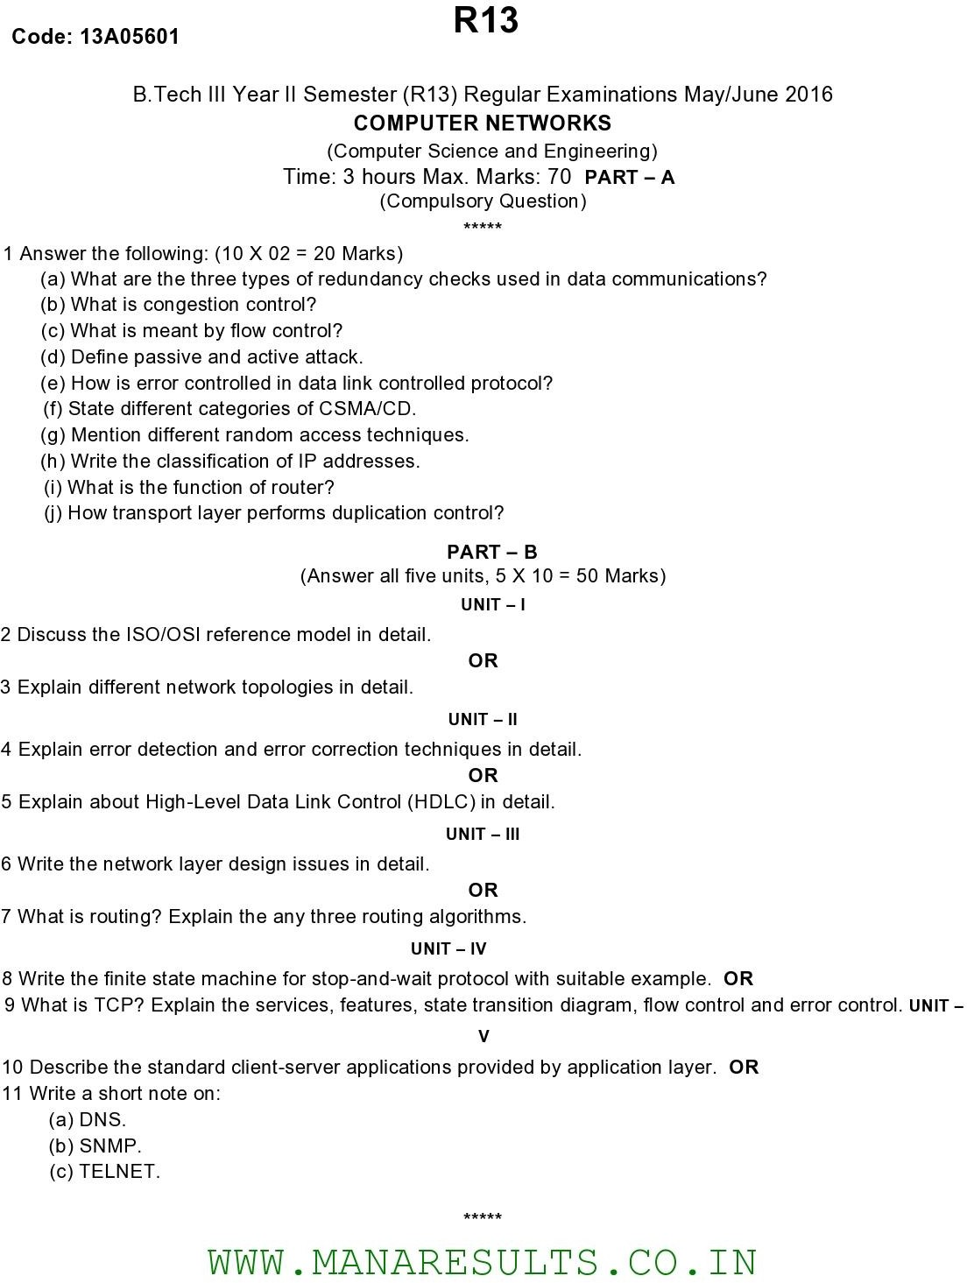

SRINIVASA RAMANUJAN INSTITUTE OF TECHNOLOGY

(Affiliated to JNTUA & Approved by AICTE and Accredited by NAAC with A Grade,Accredited by NBA(ECE,EEE,CSE))

Rotarypuram Village, B K Samudram Mandal, Ananthapuramu - 515701.

Department of Computer Science and Engineering

|  |  |  |  |  |  |  |
| --- | --- | --- | --- | --- | --- | --- |
| **Course Title:** | **Computer Networks** | | | | **Course Code:** | **204GA05502** |
| **Class & Sem:** | **III B. Tech I Sem** | | | | **Regulations:** | **R20** |
| **Course Structure:** | **Theory** | **Tutorial** | **Lab** | **Theory** | **Core/Elective** | **Core** |
| **3** | **-** | **-** | **3** |
| **Instructor 1:** | **Mr.C.Lakshminatha Reddy** | | | **AY:** | **2022-2023** | |

|  |  |  |  |
| --- | --- | --- | --- |
| **S.No.** | **CO’s** | **Target Level** | **Attained Level** |
| 1 | CO1 | **2.5** |  |
| 2 | CO2 | **2.5** |  |
| 3 | CO3 | **2.5** |  |
| 4 | CO4 | **2.5** |  |
| 5 | CO5 | **2.5** |  |
| 6 | CO6 | **2.5** |  |

**Remarks:**

**1.**

**2. 3.**

**4.**

**5**

**Course Instructor HOD**

## logo_final.jpgSRINIVASA RAMANUJAN INSTITUTE OF TECHNOLOGY

(Affiliated to JNTUA & Approved by AICTE and Accredited by NAAC with A Grade,Accredited by NBA(ECE,EEE,CSE))

Rotarypuram Village, B K Samudram Mandal, Ananthapuramu - 515701.

Department of Computer Science and Engineering

**Action taken report on Result Analysis**

As per the discussion in department meeting on result analysis which is mentioned on minutes of meeting date: The following are the suggestions and methodologies in teaching and learning in brain storming session with all faculty members.

**Best Practices:**

**1. 2.**

**3.**

**4.**

**5. 6.**

**Further Improvement:**

**1.**

**2. 3.**

**4.**

**5.**

**6.**

**Course Instructor HOD**

#### Pedagogy report:

